Madera South High School

2015 Football Schedule

Varsity Schedule

**DAY DATE OPPONENT SITE TIME DEPARTURE**

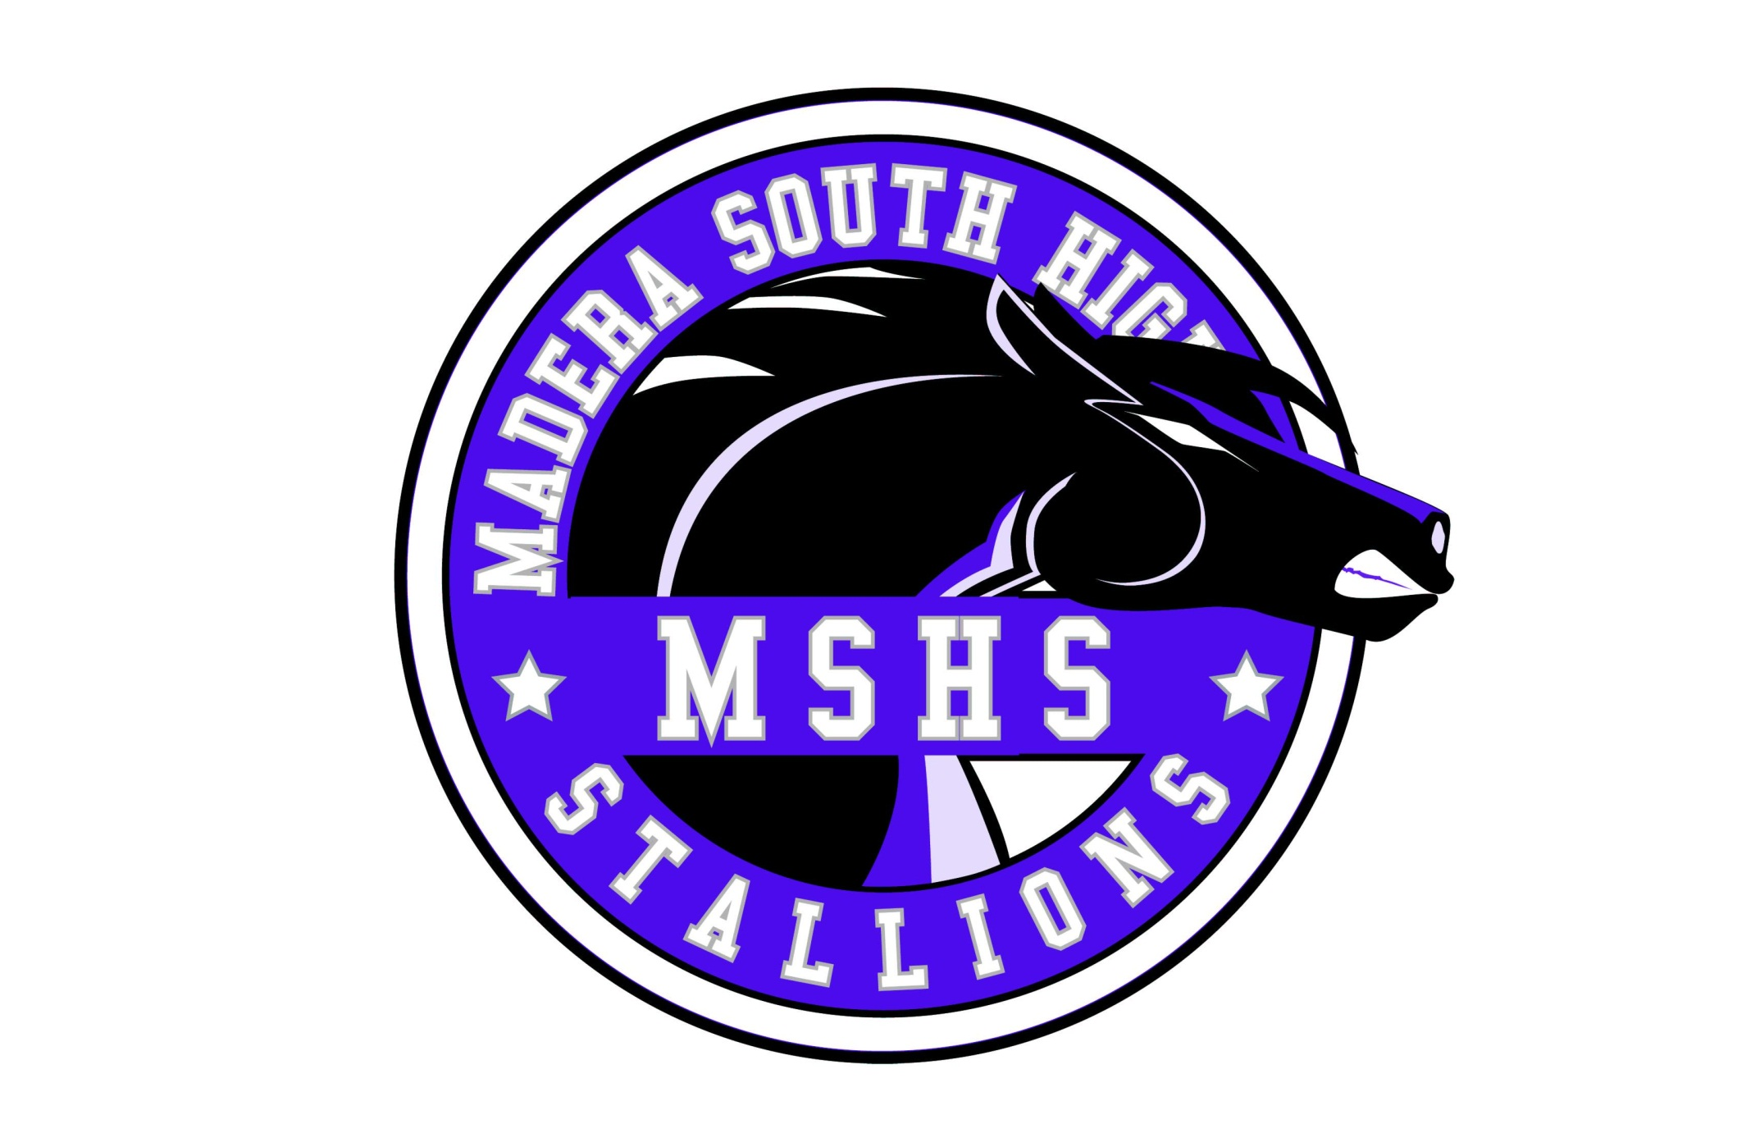(s)Friday 8/21 Washington Union(S) Washington Union 7:00 PM

Friday 8/28 Chowchilla Chowchilla 7:00 PM

Friday 9/4 Kerman Kerman 7:00 PM

Friday 9/11 Liberty Ranchos Liberty Ranchos 7:00 PM

**Friday 9/18 Exeter MSHS*Youth Football/Cheer*  7:30 PM**

**Friday 9/25 Fresno MSHS*Homecoming* 7:30 PM**

Friday 10/9 Sanger* Sanger 7:30 PM

**Friday 10/16 Bullard* MSHS*Band Night* 7:30 PM**

Friday 10/23 Edison* Edison 7:30 PM

**Friday 10/30 San Joaquin Memorial MSHS* *Senior Night* 7:30 PM**

**Friday 11/6 Madera* MSHS 7:30 PM**

Friday 11/13 Playoffs TBA

Friday 11/20 Playoffs TBA

Friday 11/27 Playoffs TBA

Friday 12/4 Playoffs TBA

Fri-Sat 12/11-12 State Regional Bowl Game

Junior Varsity Schedule

**DAY DATE OPPONENT SITE TIME DEPARTURE**

(s)Friday 8/21 Washington Union(S) WU 5:00 PM

Friday 8/28 Chowchilla Chowchilla 5:00 PM

Friday 9/4 Kerman Kerman 5:00 PM

Friday 9/11 Liberty(Ranchos) Liberty Ranchos 5:00 PM

**Friday 9/18 Exeter MSHS 5:00 PM**

**Friday 9/25 Fresno MSHS 5:00 PM**

Friday 10/9 Sanger Sanger 5:00 PM

**Friday 10/16 Bullard MSHS 5:00 PM**

Friday 10/23 Edison Edison 5:00 PM

**Friday 10/30 San Joaquin Memorial MSHS 5:00 PM**

**Friday 11/6 Madera MSHS 5:00 PM**

Freshman Schedule

**DAY DATE OPPONENT SITE TIME DEPARTURE**

Thursday 8/27 Clovis North Clovis North 4:30 PM

Thursday 9/3 Selma Selma 5:00 PM

Thursday 9/10 Hoover Hoover 5:00 PM

**Thursday 9/17 Exeter MSHS 5:00 PM**

**Thursday 9/24 Fresno MSHS 4:00 PM**

Thursday 10/1 Robert Kennedy Robert Kennedy 5:00 PM

Thursday 10/8 Sanger Sanger 4:00 PM

**Thursday 10/15 Bullard MSHS 4:00 PM**

Thursday 10/22 Edison Edison 4:00 PM

**Thursday 11/5 Madera MSHS 5:00 PM**

(s) = Scrimmage

* = League Game

Principal: Mr. Oracio Rodriguez

Athletic Director: Andrea Devine

Head Coach: Dane Cook

Colors: Purple, Black, Silver

Mascot: Stallions