Targeting Voting devices in Inspire.

After opening Inspire, click on the Express Poll button on your Main Toolbar.

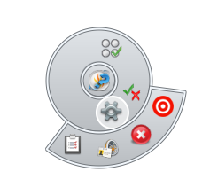

Click the Gear on the icon and a menu will “pop” out of it.

Click the target and then select the device you intend to use. And you should be good to go for the seesion.

Look for this Icon on your screen somewhere.

Click on it.



Macintosh HD:Users:dawson_m:Desktop:Screen shot 2011-12-05 at 10.27.46 AM.png