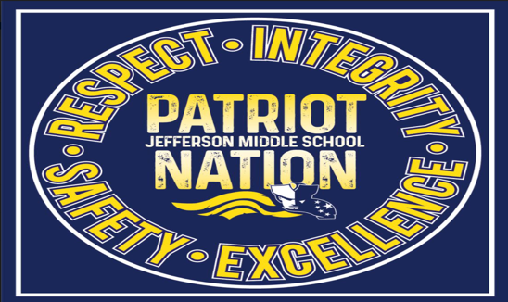

**R**ESPECT

**Hallway**

**EXPECTATIONS**

**Transit**

**B**

**R**

* **Show your Patriot spirit**
* **Model acceptable behavior**
* **Be a leader**
* **Be conscious of classes in session**

E

EXCELLENCE

* **Keep hands, feet, and objects to yourself**
* **Pay attention to half circles to avoid doors**
* **Walk with a purpose**
* **Be an active listener**

S

* **Notify staff when any type of attention is needed**
* **Follow all school rules**
* **Follow the dress code**
* **Timely usage of the restroom**

SAFETY

**I**

**I**NTEGRITY

* **Keep moving calmly and quietly**
* **Use appropriate language and greetings**